Compatibility of environmental sustainability and social justice: Insights from analysis of environmental intrusion in England, early 1960s-2007

School of Geography Working Paper

October 2008

Gordon Mitchell
The School of Geography and Institute for Transport Studies
The University of Leeds,
Leeds, UK
LS2 9JT

g.mitchell@leeds.ac.uk
Tel: 0113 343 6721

Paul Norman
The School of Geography
The University of Leeds,
Leeds, UK
LS2 9JT

p.d.norman@leeds.ac.uk
Tel: 0113 343 8199

Compatibility of environmental sustainability and social justice: Insights from analysis of environmental intrusion in England, early 1960s-2007

Abstract
The notion that environmental sustainability and social justice are compatible has been described as wishful thinking, but a hypothesis that remains to be empirically tested (Dobson, 2003). In this study, the evolution of environmental inequality in England over four decades is described, in an attempt to characterise contemporaneous changes in environmental quality and its social distribution over that time. Environmental quality is described using secondary source GIS modelled data on environmentally intrusive development, and its social distribution assessed with respect to the Townsend Material Deprivation score of districts and corroborated against the Breadline Britain index. Results reveal a clear environmental inequality, but not one interpreted as unjust, due to the underlying causal processes thought to operate, and the justice concept applied. The results do not indicate that environmental sustainability and social justice are compatible, but cannot be used to infer that the reverse is therefore true, as the conceptions of sustainability and justice prove to be insufficiently resolved. The study thus supports and illustrates Dobson’s theoretical argument, that to test the compatibility of environmental sustainability and social justice, empirical work is needed in which the component conceptions of these concepts are carefully selected and tested.

Keywords:
Environmental sustainability, social justice, environmental justice, inequality, deprivation.

Introduction

Environmental justice, evidence and response
Environmental Justice (EJ) is concerned with the fair distribution of environmental costs and benefits, and has emerged as a key theme in the sustainable development paradigm, bridging primary goals of environmental protection and social justice. EJ is conceptually very broad, addressing distribution of environmental impacts and capital (environmentally derived goods and services) within the current generation, between generations and between people and the natural world. However, historically the principal focus of the EJ movement has been on intra-generational equity issues, particularly those related to exposure to environmental hazard. In this context, Cutter (1990) defined EJ as “equal access to a clean environment and equal protection from possible environmental harm irrespective of race, income, class, or any other differentiating feature of socio-economic status”, a definition that encompasses the two key elements of EJ; distributive and procedural justice.

In the USA, numerous studies conducted since the 1970s concluded that environmental hazards, such as toxic waste disposal facilities, were disproportionately sited nearby predominantly black and low income communities, and charges of ‘environmental injustice’ subsequently led to major EJ policy initiatives. These included a Presidential Order (President, 1994) directing federal agencies to ensure that minority communities are not disproportionately affected by adverse environmental burdens, and the establishment of an EJ office in the Environmental Protection Agency. In Europe, EJ has more recently emerged as an important policy issue. Unlike the USA, where policy developed in response to grass roots civil rights activism, European EJ policy is being shaped largely at the international level, in response to the Aarhus Convention on the Environment (UN ECE, 1999), and subsequent EU directives on: ‘Public Access to Environmental Information’ (EC, 2003a); ‘Participation in Environmental Decision Making’ (EC, 2003b); and ‘Access to Justice in Environmental Matters’. Whilst the first two of these directives are in force, the EJ directive remains at the proposal stage (EC, 2003c) due to disagreement amongst member states as to who is eligible to bring a case to court on environmental injustice grounds, reflecting fears that if all are eligible, the courts will be swamped and development paralysed. The Aarhus convention is, however, being applied in full to EC institutions and bodies under recent regulation (EC, 2006). Also, the UK has seen major policy speeches on EJ by the Prime Minister (and the First Minister in Scotland), EJ research programmes supported by the Environment Agency and Scottish Executive, and EJ is a policy goal of the National Sustainable Development Strategy (HMG, 2005).

The evidence base for environmental inequality in Europe is rather limited (EC, forthcoming), with most studies conducted in the UK where there is a more well-developed EJ movement, although not on the scale of the USA. Noting concerns raised over the quality of the USA evidence base (Bowen 2002, Bowen and Wells 2002), empirical analyses of the social distribution of environmental burdens in the UK have largely pursued national coverage, small-area studies which are better able to provide a robust picture of environmental inequalities than studies of population samples. These studies revealed clear inequalities in the social distribution of environmental risk and quality, including that:
- 2.5 million people live in wards where Nitrogen dioxide (NO₂) exceeds the National Air Quality Strategy annual mean standard, of which more than half are in the most deprived wards in the country (Mitchell and Dorling, 2003);
- Integrated Pollution Control sites are more clustered in deprived areas, with greater numbers of emission sources presenting a greater pollution hazard and producing more offensive emissions than in less deprived areas (no social gradient in the rigour of IPC inspection by regulators is evident) (Walker et al, 2003);
- Of those people resident close (<1km) to a waste incinerator or other waste disposal facility, 52% are in the most deprived households, compared to 4% in the least deprived households (Walker et al, 2003);
- Children living in the most deprived areas are five times more likely to be killed in a road accident as children in more affluent areas (HMG, 2005: p135);
- For every affluent household (upper decile) in a coastal flood risk area, there are eight households from the most deprived class (lower decile). Deprived households are more vulnerable to flooding, as they often lack insurance to aid recovery (Walker et al, 2003).
- A range of studies indicate that deprived communities are exposed to much greater levels of cumulative impacts, to local incivilities (fly-tipping, neighbourhood noise etc), and enjoy poorer access to environmental goods and services (see review in Lucas et al., 2004).

Following such studies, a government commissioned review concluded that: “environmental injustice is a real and substantive problem within the UK; problems of environmental injustice afflict many of our most deprived communities and socially excluded groups; both poor local environmental quality and differential access to environmental goods and services have a detrimental effect on the quality of life experienced by members of those communities and groups; and that in some cases not only are deprived and excluded communities disproportionately exposed to an environmental risk, they are also disproportionately vulnerable to its effects” (Lucas et al., 2004). The review argued for more research into the causes of environmental injustice to support the development of appropriate policy measures. This position is echoed by the UK Sustainable Development Strategy, which outlined government intention to, in the short term, focus on improving the environment in areas already identified as most deprived, and in the long term, to conduct further research on the causes of environmental inequality and the effectiveness of measures to tackle it (HMG, 2005, pp133-5).

Assuming that an environmental injustice exists (an unequal distribution is not necessarily unjust) then what measures could be used to address it? One approach is intervention to reduce the proximity of minority communities to environmental hazard. This may involve redirecting the hazard, say using the planning system, to ensure communities do not become ‘hazard havens’ where the presence of one hazard makes it easier to gain development consent for others. Apart from problems of defining communities in terms of a population definition and their geographical extent, difficulties with this approach include: the issue of whether distributing hazards more widely places more people in total at risk; the ‘not in my back yard’ syndrome (whereby persons more able to protest about a development in their area gain an advantage over the less able elsewhere); and whether it is right to deny communities wider benefits, such as jobs, that development projects may bring to an area. Conversely, the proximity of hazard and minority community may be reduced by policies that reduce factors restricting where minority households are able to live, and which encourage social mixing. Housing development policy, for example, could be used to ensure that new developments contain a significant share of social housing, rather than developing bulk social housing in areas which tend to be less desirable. Another approach to tackling inequalities is to not attempt to change them, but provide compensatory benefits such as enhanced community health or education services, or improved housing (Blackman 2006). This may be appropriate where one group bears a burden on behalf of the wider community who enjoy benefits associated with the hazardous facility or process, without themselves bearing a proportionate environmental risk.
However, such measures have received little serious implementation attention, and currently, the most popular approach to addressing environmental injustice is to raise environmental quality in the expectation that this will reduce inequalities. As noted above, the current UK government approach is to do this in what might be called “pollution-poverty hotspots”, but in principle, raising environmental quality overall may also have a profound effect on the overall social distribution of the environmental burden. This is illustrated in two UK studies of the social distribution of air quality (as modelled NO₂). The first (Walker et al., 2003) compared the social distribution of air quality for England in 2001 and 2010, and illustrated that improvements in air quality achieved by 2010 would reduce the total number of deprived households in areas deemed of poor air quality. Secondly, Mitchell (2005) found that, when comparing a range of urban traffic management measures for Leeds, UK, including a number of road pricing scenarios, improvements in air quality and road network performance could both be achieved without a decline in air quality in deprived neighbourhoods (a common concern with road pricing measures which may cause a re-routing of trips to avoid charge zones).

Environmental sustainability and social justice
Unfortunately, evidence that improving environmental quality can bring about more socially just environmental distributions is very limited. The air quality studies cited above use static deprivation data, thereby ignoring any dynamic interaction between environmental and social metrics. Thus these particular studies are more suited to impact assessment than understanding how environmental inequalities evolve. What is really needed is longitudinal analysis of observed data, which can reveal how social and environmental variables co-vary over time. EJ process studies have been conducted in order to better understand how inequalities arise, but these have tended to take a narrative approach (e.g. Pulido 2000 on the history of hazardous industrial development in Los Angeles). Been and Gupta (1997) and Baden and Coursey (2002) conducted empirical time-series analyses in their studies of hazardous waste facility siting in the USA, but generally such empirical longitudinal analysis are rare, constraining the ability to draw more general conclusions as to whether environmental improvement also promotes EJ.
Such empirical analyses are needed, as it is rash to assume that improving environmental quality is always socially progressive, with environmental benefits accruing disproportionately to the most disadvantaged. Indeed, it has been argued that: “… social justice and environmental sustainability are not always compatible objectives. Assertions to the contrary are more often, I think, based on wishful thinking rather than on clear sighted analysis of hard empirical evidence” (Dobson, 2003: p83). Andrew Dobson is arguing here from a theoretical perspective, in part of necessity because he finds no theoretically informed empirical evidence on the topic. By theoretically informed, he means the testing of hypotheses on the relationship between environmental sustainability and social justice, such as a proposed working hypothesis that “the environmental justice movement is not a movement for environmental sustainability” (Dobson, 2003: p85). In this case, it might be assumed that environmental sustainability has the objective of reducing environmental impact (e.g. tonnage of waste to be disposed of), whilst social justice has the objective of ensuring the environmental impacts (e.g. of waste incinerators, landfills) are more fairly distributed by social class or race.

Dobson argues that whilst movements for social justice and environmental sustainability may share some common environmental ground, they have different objectives, and that measures to achieve one objective may constrain ability to meet the other. He argues that empirical research is needed which tests more formally the type of working hypothesis outlined above, but notes that, whilst the concepts of environmental sustainability and social justice are not generally contested, their constituent conceptions are. These conceptions address such questions as, for environmental sustainability, what feature of the environment is to be sustained, for how long, for whose benefit; and in the context of social justice, what constitutes an environmental burden or benefit, what is meant by ‘fair’, and who decides? Dobson suggests that the compatibility of environmental sustainability and social justice needs testing via a hypotheses produced by the intersection of these facets. Thus Dobson (pp87-90) begins with nine hypotheses addressing the questions “is distribution according to need (or desert, or merit) compatible with sustaining critical natural capital (or biodiversity, or the value of natural objects)?”

Formal testing of such hypotheses offers the scope to determine the extent and nature of the (in)compatibilities between environmental sustainability and social justice. Our exploratory analysis here is a case study of England over the last forty years or so, examining changes in a composite measure of environmental quality, and in social justice as indicated by the social distribution (by deprivation status) of that environmental quality. Whilst our study is not able to provide formal hypothesis testing as Dobson advocates, it can at least characterise how these two measures vary over time. If environmental quality has improved and the distribution of those improvements disproportionately falls on more deprived communities (or if the converse is true – environmental impacts do not fall on the more deprived communities), then there is optimism that environmental sustainability and social justice objectives could, after all, be compatible. A substantial research programme, beyond the scope of this current paper, would be required to provide the empirical evidence to support or refute the relevant hypotheses. Our ambition here is rather more modest, and is aimed more at the level of the crude working hypothesis described above. Thus our aim is to provide an empirical description of contemporaneous changes in environmental sustainability and social justice.

Data

Overview
In this paper, we present an EJ analysis using data for England on environmental intrusion (see below) and social deprivation at three points over the last forty years. Judged by the standard of the recent UK small-area studies, this EJ analysis is somewhat coarse as our spatial unit is the relatively large local authority districts. However, to our knowledge, this is the first empirical study of environmental inequality with a national coverage that has attempted any form of longitudinal analysis. The results are hopefully useful in providing a first look at how environmental inequality has evolved in the UK, and may have relevance for other countries with similar development profiles.

A major constraint on robust EJ analysis is the availability of environmental data that is presented in a consistent manner for the study area of interest, and at a useful spatial unit of analysis. Thus, as noted above, there are relatively few national level small-area analyses. These problems are further compounded when attempting a longitudinal analysis, and are likely one reason that Dobson finds no empirical evidence that tests hypotheses addressing the compatibility of environmental sustainability and social justice objectives. For our analysis, we use secondary data on environmental intrusion in England, reported in a recent study commissioned by the Campaign to Protect Rural England (CPRE) and conducted by Land Use Consultants (2007), and deprivation data, measured using the Townsend material deprivation index (Townsend, 1987; Townsend et al., 1988) with relationships corroborated against the geographical distribution of poverty using the Breadline Britain index (Gordon, 1995; Dorling, et al., 2007).

Environmental intrusion
The CPRE study provides three maps of environmental intrusion in England, for the ‘early 1960s, ‘early 1990s’ and 2007. The first two maps were produced in 1995 for the CPRE and the then Countryside Agency, who wanted to track the loss of ‘tranquil’ areas, which were defined as areas sufficiently far from visual or noise intrusion of development and traffic to be considered unspoilt. The 1995 CPRE study was criticised on the grounds that it only considered detractors from tranquillity, ignoring factors that contribute to it, and failed to take public perceptions into account when defining tranquillity criteria. These issues are addressed in more recent tranquillity maps (Land Use Consultants, 2007, p1), but not in the 2007 CPRE map, as methodological consistency across the three years was critical to the comparative study. To avoid confusion with recent tranquillity mapping studies, the three CPRE maps are referred to as environmental intrusion maps. Thus the factors addressed are only detractors, and criteria and relevant thresholds have been determined through consultation with experts, rather than seeking the views of the public. This intrusion data is well suited to EJ analysis.

Factors addressed in the intrusion maps are presented in Table 1, together with relevant buffer distances and data sources. The early maps were not made from raw data (now unavailable), but were digitised from 1:750,000 scale (AO size) hard copy maps and geo-referenced to 2007 digital boundaries. Whilst the criteria and thresholds are reported for the earlier maps, full details of data sources were not, hence the first two maps are for the ‘early’ 1960s and 1990s, rather than specific years (it is anyway likely that component data would be sourced from several years, as with the 2007 map, which is based on data for years between 2001 and 2007).
In developing the 2007 map, the authors expended significant effort to ensure consistency across years, although ambiguity over some of the thresholds and data sources used in the earlier maps means some inconsistencies are likely (e.g. it was not clear what was meant by a “heavily trafficked” railway in early mapping, or how heavy industrial areas were represented). However, the authors assert that there is a high degree of consistency in the intrusion mapping across the years, and that the results are able to support a comparative assessment of intrusion over time. Note that several factors have been addressed in previous single issue environmental equity analyses, either directly (e.g. power stations and mineral extraction sites were addressed by Walker et al., 2003), or indirectly (e.g. roads, urban areas, power stations collectively contribute to atmospheric emissions). Thus, although this data was originally derived to assess loss of tranquillity from development, it clearly has resonance with the environmental focus of many of the recent UK national small-area EJ analyses. The addition of factors not previously addressed (such as power lines and wind farms), as well as the longitudinal nature of the analysis, add new elements to the growing UK EJ evidence base.

Note that the intrusion data is ‘semi-modelled’. That is, there are not the assumptions and uncertainties involved in a deterministic model (e.g. of air quality), but the intrusion data is mapped based on observed characteristics of factors (e.g. extent of urban development, location of roads and their traffic flow), which we can be reasonably confident of, but also assumptions as to human response to those factors in terms of perception of intrusion. That is perception of intrusion is likely to vary from person to person. Thus the buffer distances adopted by the authors are subject to uncertainty. Note also that in developing an intrusion map based on buffering distance from various activities, the environmental equity analysis is essentially a proximity analysis and so has all the caveats of this (e.g. noise emission is a less satisfactory measure than noise exposure) that are reported in detail elsewhere (Mitchell and Walker, 2007).

Each map was then divided into regions defined using OS BoundaryLine 2006 data, and the land area subject to environmental intrusion calculated. Our analysis is based on the intrusion data for the 117 local authority districts, comprising Counties, Unitary Authorities and Metropolitan Districts (Land Use Consultants, 2007: Table 12). Table 2 provides a regional summary of this intrusion data. Note that the methods used to develop the intrusion maps mean that, in principle, it would be possible to conduct an EJ analysis using a smaller spatial unit of analysis, which is usually desirable in EJ analysis (Mitchell and Walker, 2007). However, to do this would require access to the original primary data. This spatially more detailed analysis has potential in future, should the district level analysis prove fruitful.

Deprivation
In the UK the principal social concern within the EJ movement is not ethnicity, as in the USA, but deprivation, as: it is the principal concern of government with respect to social exclusion; the main EJ expressions of concern at grass roots level are with respect to poverty; and there is little evidence that ethnic groups bear a disproportionate burden of environmental impacts (but little research has been done). Note also that in the USA, many claims of ‘environmental racism’ proved suspect, as the supporting studies gave insufficient attention to controlling for auto-correlation between race and poverty (Bowen, 2002).

Deprivation can be defined as a state of disadvantage relative to the local community, wider society or nation to which an individual, family or group belongs (Townsend 1987). People can be deprived of adequate education, good quality housing, rewarding employment, sufficient income, good health and enjoyment opportunities (Dorling 1996). Dating back to the 1970s, to identify relatively deprived areas in the UK, various indexes have been devised including: the Jarman Underprivileged Area index (1983); the Townsend index (1987); the Carstairs index (Carstairs and Morris 1989); Breadline Britain (Gordon 1995; Dorling et al. 2007); the Index of Local Conditions (DoE 1983 and 1994); the Index of Local Deprivation (Noble et al. 2000); and the Index of Multiple Deprivation 2004 (IMD 2004). Indexes have also been developed in the US, Canada, New Zealand and elsewhere (Bell et al. 2007). UK indexes have mainly been at electoral ward scale and are predominantly based on a composite of census-derived variables indicating relative conditions between areas, although in the recent IMD (2004) alternative geographies and input variables are used.

Deprivation measures are highly influential on the allocation of public resources (Blackman 2006; Brennan et al. 1999; Chatterton and Bradley 2000; Simpson 1996) and are often used as explanatory variables in models of various outcomes, including health, in both the UK (Boyle et al. 2002; Dibben et al. 2006; Diez Roux 2005; Law and Morris 1998; Norman et al. 2005; Norman et al. 2008) and in other countries (Karpati et al. 2006; Lorant et al. 2001; Pearce et al. 2006; Tello et al. 2005). Choice of index to use is debated (Davey Smith et al. 2001; Mackenzie et al. 1998) but a high degree of correlation between schemes is found (Hoare 2003; Morris and Carstairs 1991).

Currently, the IMD is the government’s preferred measure of material deprivation in England, which it measures across six domains using 33 variables. (Similar, but not directly comparable, IMDs have been developed for the other UK countries). The IMD was introduced in 2000 (and has been subject to several revisions since), so there is insufficient public domain data to support analysis earlier than 2000, whilst the relative complexity of the index means that to construct historical data sets, with the required internal consistency, is not feasible for this study. The Index of Multiple Deprivation and its predecessors are not comparable over time (Dorling et al. 2007). Since its input variables (see below) are available and robust enough over time, we focus on the Townsend Index of Material Deprivation (Townsend et al., 1988) one of the best and most widely used indices available (National Centre for Health Outcome Development, 2005), though now superseded by the IMD in many applications.

Townsend scores are based on four variables selected to represent: lack of material resources and insecurity, material living conditions, wealth and income. These are unemployed residents aged 16-59/64 as a proportion of all economically active residents aged 16-59/64; households without access to a car as a proportion of all households; households that are not in owner occupied accommodation as a proportion of all households; and overcrowded households (> one person per room) as a proportion of all households. The unemployment and overcrowding variables are log transformed to produce less skewed distributions, and the variables then expressed as standardised z-scores and summed, with each variable being given an equal weight, to give a final score. Higher scores indicate greater levels of material deprivation.

Given the debate on the merits of variables included in different schemes (see Bradford et al. 1995; Eroğlu 2007; Senior 2002), in this context, we should consider the applicability of the input variables over time. Essentially there is no difference in meaning over the study period of what is meant by unemployment, overcrowding and non-ownership of home or car so different levels of these variables should provide a useful indication of change in aggregate population characteristics. Less justifiable over time might be variables used as deprivation indicators in other schemes such as: lacking household amenities or central heating; born in the New Commonwealth; and socio-economic group.

Raw data are available from the 1971, 1981, 1991 and 2001 Censuses so we can calculate Townsend scores for this period but not for the earlier decade. The input variables have been transferred from the census geographies by which they were originally disseminated to be consistent with the district boundaries used in the CPRE study (using the method of Norman et al. 2003) with deprivation scores then calculated for that geography. Conventionally, Townsend scores (and other area measures) are time-point specific. Observations for areas for each input variable are expressed relative to that variable’s national rate (using z scores), e.g. a location’s unemployment rate is relative to UK unemployment rate. Here we needed to identify change between time-points. To achieve this, numerators and denominators of the four input variables for 1971 to 2001 were stacked in one file. Thus, when calculating deprivation, for each CPRE district, rates in every year for each variable are expressed relative to the UK 1971-2001 average of that variable. The resulting Townsend scores are then comparable so that if an area changed from a (relatively deprived) score of +6 in 1991 to +5 in 2001 then, according to the composite of the input variables, the area became less deprived over time.

Figure 1 shows how the national level of each indicator variable changed between 1971 and 2001 (including 1981 for illustrative purposes though this year is not used in our analysis). Levels of non-home and no-car access steadily decline through the period along with a reduction in household overcrowding which has become increasingly rare. Unemployment rose after 1971, being relatively high in both 1981 and 1991 when the economy was in recession. Unemployment was much lower in 2001. The resulting distributions of Townsend scores across the CPRE districts are illustrated by boxplots in Figure 2 with the mean deprivation gradually reducing over the period along with reductions in the range and standard deviation.

An alternative scheme through which to investigate intrusion-deprivation relationships over time is to use the Breadline Britain index. The Breadline Britain method measures relative poverty based on a lack of the perceived necessities of life. Items defined as necessities are those that more than 50% of the population believes “all adults should be able to afford and which they should not have to do without” (Gordon et al. 2000). Dorling et al. (2007) note that this approach can be replicated for a time series when census data and poverty surveys occur at roughly the same time and that this has been the case approximately every 10 years since 1970. The method uses information from detailed household poverty surveys to classify each household as ‘poor’ or ‘not poor’. The survey includes information comparable to the census, such as household composition, tenure, car ownership and social class. The survey data is analysed to assess the relationship between these census-type variables and the poor/not poor classification of households in the survey. These relationships are then applied to census area data to estimate the number of poor households in each location and have been used to create a time-series relating to approximately 1970, 1980, 1990 and 2000. The main variable of interest is the percentage of households which are ‘Breadline poor’. These households are under the poverty line, defined theoretically as the resource level that is so low that people are excluded from participating in the norms of society (Dorling et al. 2007). To achieve geographical consistency over time, the Breadline Britain data has only been released for relatively coarse geographies which lack the versatility of the ward level data for which we have input data for the Townsend index. Whilst this is not problematical in terms of the study reported here which is for broad regions, should more local environmental intrusion data become available, the lack of Breadline data at a consistent small area scale over time would be restrictive. Moreover, the use of the Townsend index will mean that distributions of individual deprivation indicator variables can be compared with environmental intrusion to determine relationships with particular dimensions of deprivation. For these reason we focus on the use of the Townsend but, for corroboration, will present sample findings using the Breadline Britain index.

Dorling et al. (2007) note that the geographical pattern of poverty revealed by the Breadline Britain scores demonstrates similar geographical distributions at every time period but that Britain became less polarised during the 1970s and then increased through the 1980s and 1990s. This is revealed for the geographical areas used in the CPRE study in Figure 2b which shows that the percentage of households below the poverty line decreased between 1970 and 1980 but then increased up to 2000. The difference in pattern with the overall change in Townsend scores illustrated in Figure 2a is because the perceived necessities of life are reappraised every ten years with the poverty level re-set, whereas the Townsend scores are relative to the same level throughout the time period. Despite their methodological differences, Figure 2c shows that, for the CPRE district geography there is a strong positive relationship between the Townsend scores and Breadline Britain index. The relationship is strong in the early 1970s (correlation, 0.88) and then increases by the early 1980s (correlation, 0.98) remaining at that level to the early 2000s. The similarities in the distributions of the Townsend and Breadline Britain schemes suggests that when related to environmental intrusion very similar results will emerge.

Our analysis seeks to describe contemporaneous variation in deprivation and environmental intrusion in England. However, data constraints preclude the use of environmental and social data sets drawn for the same years, and our datasets must of necessity relate information for broadly equivalent periods. Thus the 2007 period relates 2001 deprivation data to the 2001-2007 intrusion data; the 1990s period relates 1991 deprivation data to intrusion data collected for ‘the early 1990s (up to 1995); whilst the earliest analysis relates 1971 deprivation data to intrusion data for the ‘early 1960s’ (exact years unreported). This is not ideal, but given the time span of the analysis exceeds forty years, we feel these discrepancies are not sufficient to preclude identification of the general variation in environmental equity occurring over the study period. We use basic descriptive statistics, including population weighted histograms (popular in recent national small-area EJ studies) in our analysis. These are simple, but because we are dealing with a population, rather than a sample, they are able to provide a powerful description of the observed patterns.

Results
Figure 3a illustrates the relationship between Townsend deprivation and environmental intrusion area for the 117 districts in England, for each of the three time periods described above. Over time, there has been a clear shift in the distribution for both variables. Deprivation has eased significantly (high positive values indicate most deprived), with the ‘cloud’ of points gradually and consistently moving from right to left consistent with the boxplots in Figure 2. Over the same period, intrusion increased, with the most noticeable change with respect to intrusion extremes. Between the 1960s and early 1990s the number of districts with low levels of intrusion fell substantially (from 17 to 7 districts with <20% intrusion by area, falling to just one district by 2007). Conversely, the increase in districts where no area is left without some form of environmental intrusion was relatively modest between the early 1960s and 1990s (a rise from 10 to 15 districts over three decades), but substantial from the 1990s to 2007 (a rise from 15 to 33 districts with 100% intrusion over c. 15 years). These data illustrate that many districts have reached a ‘saturation’ level of environmental intrusion where there are no areas left undisturbed by visual or noise intrusion. This increase has been particularly marked since the early 1990s.

Similarly, for each time period and CPRE district, Figure 3b illustrates the relationship between poverty as indicated by the Breadline Britain index and environmental intrusion area. The cloud of points moves up the y axis as intrusion increases through time such that the number districts with very low levels of intrusion in the early 1960s decreases by the 1990s and then further by 2007. Concurrently, the number of districts at saturation point increases. The gradual shift towards lower levels of deprivation as seen for the Townsend scores in Figure 3a is not evident because of the differences in the way the Breadline Britain index is calculated. However, the relationship between poverty and intrusion is consistent in the early 1960s, 1990s and in 2007 and does not appear likely to reveal aspects differently to the Townsend scores, especially given the close correlation between the schemes. Since we want to be able to investigate individual deprivation indicator variables and their relationship with intrusion and to retain the potential for a more geographically detailed study in the future all further work reported here uses the Townsend scores.

Figure 4 plots the relationship between Townsend deprivation and intrusion. For each time period, districts have been placed in rank deprivation order, and grouped into deciles of approximately equal population count (4.9 million people), and the decile mean deprivation score calculated. Thus the first decile comprises the most deprived districts, and the tenth decile districts that are least deprived. From these plots it is apparent that, firstly, the more deprived districts are subject to the greatest levels of intrusion, an observation consistent across all three time periods. By 2007, the most deprived quintile experiences 100% intrusion, compared to 65% for the least deprived quintile (and just 55% for decile eight). Secondly, it is evident that the least deprived districts do not enjoy the least intrusion; in the final quintile the level of intrusion increases after having fallen through the other deciles. Figure 4 also shows that, almost without exception, the degree of intrusion has increased from the early 1960s to the early 1990s, and again to 2007, for all deprivation deciles. That is, no particular group has escaped the added environmental intrusion occurring over the last four decades.

The social distribution of these increases in intrusion is not even, however. Figure 5a plots change in deprivation score from 1971 to 1991 against change in intrusion from early 1960s to early 1990s, whilst Figure 5b presents a similar plot for the early 1990s to 2007 interval. For both intervals, all districts experienced an improvement in deprivation, and the intrusion data displays an approximately normal distribution, with respect to the change in deprivation score. That is, those districts which experienced the least, and the greatest improvement in deprivation status tend also to have experienced the least additional intrusion, whilst intrusion has been greatest in those districts that experienced more intermediate levels of deprivation reduction.

These data are summarised in Figure 6, where districts have been placed in groups according to improvement in deprivation (intervals of one Townsend unit) experienced from 1971-2001. For each of these groups, the mean change in intrusion area over the associated period from the early 1960s to 2007 is then given, together with the mean deprivation score in 1971. From these data, three groups of districts can broadly be identified. The first is a group where additional intrusion over the last four decades has been very low (c. 10% of total growth in intrusion area), and where deprivation status has improved substantially (> 7 Townsend units). The second group has also experienced little added intrusion area over the last forty years (c. 9%), but its districts have experienced the least improvement in deprivation score (< 4 Townsend units). These districts include those that had intermediate levels of deprivation in 1971. A third group comprises the remaining districts, which were the least deprived in 1971, have experienced intermediate levels of improvement in deprivation status, but account for the bulk (>80% by area) of the growth in intrusion experienced since the early 1960s.

Discussion

Evolution of an environmental equity
For some conceptions of justice (e.g. a just distribution defined as one where people get what they deserve) understanding the process by which an inequality arises is important in judging whether the inequality is unfair. For other conceptions (e.g. a rights based conception of justice), the causal process is less relevant to judging fairness, but it may still be important to understand this process, so as to design effective mitigation. The EJ literature addresses many processes by which environmental inequalities may develop (reviewed by Liu, 2001). Of these, deliberate discrimination in decision-making (e.g. regarding development location or planning consent) is perhaps the only one that could be considered overtly unjust (and rarely demonstrated), and a variety of other processes have been theorized which may also produce inequality patterns (these have not been robustly tested, often due to the lack of adequate time series data).

Four main theories can be identified, relating to locational choice, risk perception, neighbourhood transition, and planning practice. Location theory argues that households locate to meet a package of needs, seeking to maximize utility (the Tiebout hypothesis). As valuation of, and ability to pay for, environmental quality is not uniform amongst households with different incomes (the affluent are deemed to give these attributes a higher value), an environmental inequality results. A similar utility maximizing process may also operate with respect to firms, which seek to minimize costs, and so may locate in low income areas where land and labour are cheaper and available.

Risk theory argues that people’s perception of risk varies according to individual and social group characteristics, thus affecting household location. Those that value the environment less than average may also perceive environmental risk as less than average, and will locate closer to the risk than average. An individual’s response to risk may also vary according to the cultural group they belong to. Neighbourhood transition theory argues that minority groups are put closer to hazards and areas of lower environmental quality through a variety of interactions between households. For example, invasion succession sees minorities arrive in a neighbourhood of low environmental quality, do well, and make it more attractive for other minorities who locate there creating a concentration of minority households in an area of low environmental quality. Alternatively, location of a hazardous facility in an area may cause more affluent householders to move away, with their properties then reoccupied by lower income groups attracted by the improved quality of housing available, thus producing a minorities concentration in close proximity to the hazard. Finally, the land use planning system usually acts to protect high quality environments by directing threats to environmental quality towards areas that are already degraded. Thus it is theorized that risks and hazards can be concentrated by the housing market: people with the means to live in higher quality protected environments do so, leaving lower income groups to locate in unprotected areas where hazards are more common. Additionally, housing developers seek to maximize returns by developing properties for high income households in areas of high environmental quality, with social housing more likely to be directed to areas of lower environmental quality.

Our study aimed to describe how the social distribution of an environmental quality measure changed over time, but not to test which of the causality theories may be operating to produce the observed distribution (further research would be required). However, in describing how the environmental equity pattern evolved nationally, over a period of four decades, it is possible to more confidently speculate as to which of the hypothesised processes may be more significant. Firstly, it is clear that by the early 1960s there was already a well established social distribution of environmental quality, with high levels of intrusion (75-85% by area) in the most deprived districts, with progressively lower levels of intrusion for less deprived districts. The exception is with the least deprived districts (fifth quintile of Figure 4) where levels of intrusion are elevated, although still well below those observed for the most deprived districts. These observations are consistent with those reported elsewhere for England, particularly those related to air quality (Mitchell and Dorling 2003, Walker et al., 2003). In these studies the decline in environmental quality amongst the least deprived deciles was interpreted as the least deprived households choosing to locate in areas of lower environmental quality than they might otherwise be expected to, so as to take advantage of alternative benefits offered by that location. For example, access to certain jobs and services is likely to be better in large urban areas where air quality tends to be below that experienced in smaller urban and rural areas. This overall pattern has essentially been maintained from the 1960s to date, during which time the level of intrusion increased across all deprivation classes.

If we consider the contemporaneous changes in deprivation and intrusion (Figures 5 and 6), a coarse longitudinal pattern emerges, with no straightforward relationship (e.g. linear correlation) between the universally observed improvement in deprivation scores and increases in intrusion. Rather, the relationship is non-linear, with relatively little growth in intrusion for those districts experiencing either little or much improvement in deprivation, and major growth in intrusion occurring in those districts that were amongst the least deprived in 1971, and which experience intermediate levels of improvement in deprivation status.

Of the three broad groups of districts identified earlier (from Figure 6), two experienced little added intrusion over the last four decades (c. 10% of total area growth). One group experienced substantial improvements in deprivation score (> 7 Townsend units), but from a very low base in 1971. This group includes the districts (Table 3) of Knowsley in the North West (the most deprived district in England in 1971) and North East districts such as Sunderland and Durham County, which were amongst the most deprived of all districts in 1971. From our knowledge of these areas, we can speculate that the limited growth in intrusion is attributable to a declining industrial economy and hence a relative lack of jobs and demand for development.

The second group with little intrusion growth has a rather different deprivation profile. Districts in this group were, on average, of intermediate deprivation in 1971, and enjoyed the smallest improvement in deprivation scores to date. These districts (Table 3) are predominantly urban districts in the North and Midlands and the large Greater London Authority district. Whilst past lack of demand for development may be a factor behind the low growth in intrusion for some of these districts, it is not a satisfactory explanation for all (e.g. those districts in the South East where the economy is more buoyant and demand for development land high). Rather, it would appear that the potential to increase the intrusion level became constrained between the early 1990s and 2007 for these urban districts, and predominantly those that are the most deprived, when maximum possible levels of environmental intrusion were reached (i.e. whole districts became affected by visual or noise intrusion).

The final group of districts is one with very high levels of intrusion growth, where deprivation levels, which were lowest of all districts in 1971, have shown intermediate improvement. This group comprises largely rural counties and districts with medium sized cities, where urban- and sub-urbanisation is likely to be responsible for the major growth in intrusion, with housing, and associated roads and other infrastructure, developed in areas accessible to major urban centres, yet attractive to developers and householders. In seeking out the benefits of suburban living, such as larger cheaper houses in attractive areas with access to major centres, householders are of course contributing to the decline in the environmental quality that they value. It is particularly telling that the CPRE districts which have experienced the largest increases in population have also seen the largest reductions in non-car access (Figure 7), which we would expect to have an association with environmental intrusion.

Of the causal processes considered above, it seems most likely that, for England as a whole, market forces working within the constraints of the land use planning system, offers the most plausible explanation for the social distribution of environmental intrusion observed in the 1960s and maintained to the present day. The possibility that other processes also act to influence this distribution cannot be discounted, but their influence is likely to be significant at a more local level, not the district scale addressed here. This remains to be tested more formally.

The ES – SJ nexus
What then, can this analysis tell us about the relationship between environmental sustainability and social justice? Table 4 illustrates four scenarios of the relationship between environmental quality and social justice. Only scenario one could support a conclusion of compatibility. Scenarios two and three demonstrate improvement in one or other of the two measures, so cannot be judged as compatible. Scenario four cannot support an interpretation of compatibility either, although if trends in both measures are a product of a common underlying causal process, reversible along the same path, then this may become scenario one (but hysteresis effects may operate). Thus our analysis provides no evidence that environmental sustainability and social justice are compatible. To do so, it would be necessary to show that over the four decades under study, environmental intrusion had declined, and that the social distribution of that intrusion had at the same time become more just (Scenario one).

However, in attempting to identify which scenario occurred, our analysis does support and illustrate Dobson’s central argument, that the broad concepts (environmental sustainability and social justice) must be explicitly defined before any conclusion as to their compatibility can more generally can be drawn. Consider, for example, the social distribution of intrusion in the early 1960s and how it changed over time. Areas of greater deprivation tend to experience higher levels of intrusion (Figure 4), but the added intrusion experienced since the 1960s has largely been in the least deprived districts of all (Figure 6). The interpretation of whether these distributions are fair can only be made if the conception of justice is defined. For those who subscribe to justice as a merit based conception, then the observed distributions are arguably just, as households locate according to their economic means (assuming the locational processes discussed above underlie the observed distributions). For those who subscribe to a needs based conception of justice, the early 1960s intrusion distribution might be considered unjust, but one that is becoming more just as the least deprived bear a greater share of the added intrusion (the distribution becomes more egalitarian).

In making these judgements, it becomes evident that the environmental measure must be carefully selected. Our intrusion measure is perhaps too blunt an indicator of environmental sustainability to permit clear interpretation against conceptions of justice. For example, we see intrusion growing fastest in the least deprived districts, but our measure addresses areal extent only, and cannot inform on the intensity or severity of intrusion. For the most deprived districts intrusion has reached saturation levels in area terms, but intrusion could continue to increase in other ways that we are not able to quantify here (e.g. growth in traffic noise on existing roads, urban infill within buffer zones of intrusion features). Thus our intrusion measure masks other environmental attributes that are potentially more useful in eliciting the relationship between environmental sustainability and social justice.

Unfortunately, the longitudinal data required to make such assessments is unavailable, but in principle, key data sets might be amenable to reconstruction through modelling. For example, given historical data on road networks, traffic flows, industrial activity etc, it should be possible to produce air quality maps for past years (1971, 1981 etc to match the deprivation data) using the same techniques (Stedman et al., 1997) as used to model air quality nationally today. If analysis then focuses on atmospheric concentrations in breach of air quality standards, it would be possible to consider a clear environmental sustainability metric (one important to public health) in respect of a clear conception of justice (a universal right to air quality compliant with health based standards). Such an analysis would be particularly interesting as the results are not intuitive; past development has increased the extent of polluting activities, but technology has substantially reduced emissions per unit activity for many pollutants.

More fundamentally, if we are to address environmental sustainability, we need a clear conception of what is meant by sustainable. For those adopting a strong sustainability perspective, intrusion may be considered unsustainable as it represents loss of ecological capital (e.g. greenspace). However, for those adopting a weaker sustainability perspective, intrusion growth may be judged sustainable, so long as the value of the ecological capital lost to that intrusive development is substituted by human capital (e.g. infrastructure) of equal value.

Conclusion
In this paper we have presented a longitudinal EJ analysis using data on environmental intrusion from a range of developments and deprivation in England spanning a period of over forty years. Data limitations mean that spatially and temporally this remains a coarse analysis, but to our knowledge, this is the first national longitudinal EJ study of its type. A clear social distribution of environmental intrusion is maintained throughout the study period, with the more deprived districts subject to higher levels of intrusion. However, the bulk of the growth in intrusion occurred in those districts which were amongst the least deprived in the earliest period analysed.

Whilst evidence for environmental inequality is clear, it is hard to argue that environmental injustice occurs, in part as the market and land use planning processes thought to underlie the observed patterns are not inherently discriminatory. If injustice does occur, it is arguably against those who suffered the greatest increase in intrusion, whilst over the same time only experiencing modest improvements in deprivation status. However, these were the least deprived in the earliest period studied, and are likely have greater opportunity to take remedial action (e.g. move somewhere better) than is case for the more economically marginal groups.

Analyses such as ours can, in principle, demonstrate that environmental sustainability and social justice are compatible, by demonstrating that the environmental measure improves at the same time as the social distribution of that measure becomes more ‘fair’ (co-variation), and also that environmental and social measures are responding to a common process (model specification), an implicit assumption of our analysis. Our study revealed no such pattern, and cannot support the hypothesis that environmental sustainability and social justice are compatible. However, it should not be used to claim that the opposite is therefore true. Rather, our study serves to illustrate and support Dobson’s argument, that testing the hypothesis that environmental sustainability and social justice are compatible requires explicit definitions of what is meant by environmental sustainability, and how just distributions are to be identified.
Our ability to test the compatibility hypothesis at the conceptually more disaggregate level (e.g. Dobson’s specific conceptions of what is meant by environmental sustainability, and by social justice) has been constrained by the availability of suitable historical environmental data. For example, were historical small-area national coverage data on air quality (an indicator of environmental sustainability) available to complement our deprivation data, then an analysis could be conducted to determine the social distribution of pollution, addressing a needs based conception of justice (the universal need for clean air), but also the social distribution of exceedence of air quality standards (concentration thresholds), thus addressing a rights based conception of justice (everyone has a right to expect air quality that complies with the legally defined standard). However, a general lack of small-area historical environmental data means that such longitudinal analyses able to test the compatibility hypotheses more robustly remains challenging. This is certainly the case for the UK at the national level, but analyses at more local geographies may be possible, although the confidence in results that a study with national coverage offers would be lost. Reconstruction of past environmental quality using more readily available data (e.g. modelling of air quality from historical traffic flow and other activity data) may prove a fruitful avenue for further investigation of the compatibility hypothesis.

References
Baden B M, Coursey D L, 2002 “The locality of waste sites within the city of Chicago: a demographic, social, and economic analysis” Resource and Energy Economics 24 (1-2) 53-93
Been V, Gupta F, 1997 “Coming to the nuisance or going to the barrios? A longitudinal analysis of environmental justice claims” Ecology Law Quarterly 24 1–56
Bell N, Schuurman N, Hayes M V (2007) “Using GIS-based methods of multicriteria analysis to construct socioeconomic deprivation indices” International Journal of Health Geographics 6 (17)
Blackman T, 2006 Placing health: Neighbourhood renewal, health improvement and complexity (The Policy Press: Bristol)
Bowen W, 2002, "An analytical review of environmental justice research: what do we really know?" Environmental Management 29 (1) 3-15
Bowen W M, Wells M V, 2002 “The politics and reality of environmental justice research: a history and considerations for public administrators and policy makers” Public Administration Review 62 (6) 688-698
Boyle P, Norman P, Rees P, 2002 “Does migration exaggerate the relationship between deprivation and limiting long-term illness? A Scottish analysis” Social Science and Medicine 55, 21-31
Bradford M G, Robson B T, Tye R, 1995, “Constructing an urban deprivation index: a way of meeting the need for flexibility” Environment and Planning A 27 519-533
Brennan A, Rhodes J and Tyler P, 1999 “The distribution of SRB challenge fund expenditure in relation to local-area need in England” Urban Studies 36 (12) 2069-2084
Carstairs V, Morris R, 1989 “Deprivation: explaining differences in mortality between Scotland, England and Wales” British Medical Journal 299 886-889
Chatterton P, Bradley D, 2000 “Bringing Britain Together? The limitations of area-based regeneration policies in addressing deprivation” Local Economy 15(2) 98-111
Cutter S, 1995 “Race, class and environmental justice” Progress in Human Geography 19(1), 111-122
Davey Smith G, Whitley E, Dorling D, Gunnell D, 2001 “Area based measures of social and economic circumstances: cause specific mortality patterns depend on the choice of index” Journal of Epidemiology and Community Health 55 149-150
Dibben C, Sigala M, Macfarlane A, 2006 “Area deprivation, individual factors and low birth weight in England: is there evidence of an area effect?” Journal of Epidemiology and Community Health 60 1053-1059
Diez Roux A V, 2005 “Estimating and understanding area health effects” International Journal of Epidemiology 34 284-285
Dobson A, 2003, “Social justice and environmental sustainability: Ne’er the twain shall meet?” In Just sustainabilities: development in an unequal world Eds. Agyeman J, Bullard R, Evans, B, (London, Earthscan) pp83-95.
DoE, 1983, Urban Deprivation: Information Note 2, Inner Cities Directorate Department of the Environment, London
DoE ,1994, A 1991 Index of Local Conditions Department of the Environment: London
Dorling D, 1996, “Be cheerful, strive to be happy identifying disadvantaged areas: health, wealth and happiness” Radical Statistics 62 8-21
Dorling, D., Rigby, J., Wheeler, B., Ballas, D., Thomas, B., Fahmy, E., Gordon, D., and Lupton, R. 2007, Poverty, wealth and place in Britain, 1968 to 2005. Bristol: Policy Press.
EC, 2003a, “Directive 2003/4/EC of the European Parliament and of the Council of 28 January 2003 on public access to environmental information and repealing Council Directive 90/313/EEC” Official Journal of the European Communities L 041 26-32 14 February (European Commission, Brussels)
EC, 2003c, “Proposal for a Directive of the European Parliament and of the Council on access to justice in environmental matters” 24 October, COM 624 2003/0246 (COD) (European Commission, Brussels)
EC, 2003b, “Directive 2003/35/EC of the European Parliament and of the Council of 26 May 2003 providing for public participation in respect of the drawing up of certain plans and programmes relating to the environment and amending with regard to public participation and access to justice Council Directives 85/337/EEC and 96/61/EC” Official Journal of the European Communities L 156 17-25 25 June (European Commission, Brussels)
EC, 2006, “Regulation (EC) No 1367/2006 of the European Parliament and of the Council of 6 September 2006 on the application of the provisions of the Aarhus Convention on Access to Information, Public Participation in Decision-making and Access to Justice in Environmental Matters to Community institutions and bodies, Official Journal of the European Communities L 264 13-19 25 September (European Commission, Brussels)
EC (forthcoming) “Links between social and environmental pillars of sustainable development, particularly the link between social cohesion/inclusion and environmental policies” European Commission (AEAT, Oxon).
Eroğlu S, 2007, “Developing an index of deprivation which integrates objective and subjective dimensions: extending the work of Townsend, Mack and Lansley, and Halleröd” Social Indicators Research 80 493-510
Gordon D, 1995, “Census based deprivation indices: their weighting and validation” Journal of Epidemiology and Community Health 49 S39-S44
HMG, 2005, Securing the future: The UK Government Sustainable Development Strategy Her Majesty’s Government (HMSO, Norwich)
Hoare J, 2003, “Comparison of area-based inequality measures and disease morbidity in England 1994-1998” Health Statistics Quarterly 18 18–24
IMD, 2004, “The English Indices of Deprivation 2004” Office of the Deputy Prime Minister, http://www.odpm.gov.uk/stellent/groups/odpm_control/documents
Jarman B, 1983 “Identification of Underprivileged Areas” British Medical Journal 286 1705-9
Karpati A M, Bassett M T, McCord C, 2006, “Neighbourhood mortality inequalities in New York City, 1989-1991 and 1999-2001” Journal of Epidemiology and Community Health 60 1060-1064
Land Use Consultants, 2007, Developing an Intrusion Map of England (Land Use Consultants, 43 Charlton Street London)
Law M R and Morris J K, 1998, “Why is mortality higher in poorer areas of England and Wales?” Journal of Epidemiology and Community Health 52 344-352
Liu F, 2001, Environmental justice analysis: theories, methods and practice (CRC Press, Boca Raton, Florida)
Lorant V, Thomas I, Deliège D, Tonglet R, 2001, “Deprivation and mortality: the implications of spatial autocorrelation for health resources allocation” Social Science and Medicine 53 1711-1719
Lucas K, Walker G, Eames M., Fay H, Poustie M, 2004, Environment and Social Justice: Rapid Research and Evidence Review. (Policy Studies Institute, London)
Mackenzie I F, Nelder R, Maconachie M, Radford G, 1998, “My ward is more deprived than yours” Journal of Public Health Medicine 20 186-90
Mitchell G, 2005, “Forecasting Environmental Equity: Air Quality Responses to Road User Charging in Leeds” Journal of Environmental Management 77 (3) 212-226
Mitchell G, Dorling D, 2003, “An environmental justice analysis of British air quality. Environment and Planning” A 35 909-929
Mitchell G, Walker G, 2007, “Methodological issues in the assessment of environmental equity and environmental justice” In Sustainable urban development volume 2: the environmental assessment methods Eds. Deakin M, Mitchell G, Vreeker R, Nijkamp, P, (Routledge, Abingdon), pp447-472
Morris R, Carstairs V, 1991, “Which deprivation? A comparison of selected deprivation indexes” Journal of Public Health Medicine 13 (4) 318–326
National Centre for Health Outcome Development, 2005, Compendium of clinical and health indicators users guide. Annex 1: Measuring deprivation (Department of Health, London)
Noble M, Penhale B, Smith G, Wright G, Dibben C, Owen T, Lloyd M, 2000, Measuring Multiple Deprivation at the Small Area Level: the Indices of Deprivation 2000 Department for the Environment Transport and the Regions, London
Norman P, Boyle P, Rees P, 2005, “Selective migration, health and deprivation: a longitudinal analysis” Social Science and Medicine 60(12) 2755-2771
Norman P, Gregory I, Dorling D and Baker A (2008) “Geographical trends in infant mortality: England and Wales, 1970–2006” Health Statistics Quarterly 40
Norman P, Rees P, Boyle P, 2003, “Achieving data compatibility over space and time: creating consistent geographical zones” International Journal of Population Geography 9 365-386
Pearce J, Witten K, Hiscock R, Blakely T, 2006, “Are socially disadvantaged neighbourhoods deprived of health-related community resources?” International Journal of Epidemiology 36 348-355
President, 1994, “Proclamation: ‘Federal actions to address environmental justice in minority populations and low income populations’" Executive order 12898 / 59 C F R 7629. 103rd Congress, Second Session”. US Code Congressional and Administrative News 6 B7-B12
Pulido L, 2000, “Rethinking Environmental Racism: White Privilege and Urban Development in Southern California” Annals of the Association of American Geographers 90 1 12 – 40
Senior M L, 2002, “Deprivation indicators”, in The Census Data System Eds. Rees P, Martin D, Williamson P (John Wiley: Chichester) pp123-137
Senior M, Williams H, Higgs G, 2000, “Urban-rural mortality differentials: controlling for material deprivation” Social Science and Medicine 51 289–305
Simpson S, 1996 “Resource allocation by measures of relative social need in geographical areas: the relevance of the signed chi-square, the percentage, and the raw count” Environment and Planning A 28 537-554
Stedman J R, Vincent K J, Campbell G W, Goodwin J W, Downing C E H, 1997, “New high resolution maps of estimated background ambient NO_{X} and NO₂ concentrations in the UK, Atmospheric Environment 31 3591-3602
Tello J E, Jones J, Bonizzato P, Mazzi M, Amaddeo F, Tansella M, 2005, “A census-based socio-economic status (SES) index as a tool to examine the relationship between mental health services use and deprivation” Social Science and Medicine 61 2096-2105
Townsend P, 1987, “Deprivation” Journal of Social Policy 16 125-46
Townsend P, Phillimore P, and Beattie A, 1998, “Health and Deprivation: Inequality and the North”. (Routledge, London)
UN ECE, 1999, “Convention on Access to Information, Public Participation in Decision Making and Access to Justice in Environmental Matters” (United Nations Economic Commission for Europe, Geneva)
Walker G, Mitchell G, Fairburn J, Smith G, 2003, Environmental Quality and Social Deprivation. Phase II: National Analysis of Flood Hazard, IPC Industries and Air Quality. R&D Project Record E2-067/1/PR1 (The Environment Agency, Bristol)
Table 1. Criteria and data used in intrusion mapping

Feature | Data set(s) used | Definition | Distance threshold
Roads | Road network from OS Strategi (2006). Annual Average Daily Traffic (AADT) Flows from GB National Road Traffic Survey (DfT, 2005). | Over 75,000 AADT | 3 km
Roads |  | 25,000 – 75,000 AADT | 2 km
Roads |  | 10,000 – 25,000 AADT | 1 km
Roads |  | 5,000 – 10,000 AADT | 0.5 km
Roads |  | Below 5,000 AADT | no disturbance
Railways | National Rail Principal Routes from OS Strategi (2006) | Mainline routes | 0.5 km
Airports | Airports and noise contours (Civil Aviation Authority) | Civil Airports, distance from 57Leq noise contour | 1 km
Airports | Military airports with jet air squadrons (MOD) | Military airports, ellipse along axis of runway | 7 km x 1 km
Built up areas | Urban Areas and Urban Area Key Statistics (ONS / Census 2001) | Over 270,000 people | 3 km
Built up areas |  | 4,000 to 270,000 people | 2 km
Built up areas |  | 2,500 to 4,000 people | 0.5 km
Areas of mineral extraction | Britpits data set for all mineral extraction sites (British Geological Service, 2007) |  | 0.5 km from point data
Electrical installations | Power Stations (CESA, 2006).  Location of 400kV and 275kV power lines and grid stations (National Grid, 2007) | Power stations | 3 km
Electrical installations |  | 400kV and 275kV power lines | 0.5 km
Electrical installations |  | Grid stations | 0.5 km
Wind power developments | Location of operational wind power developments (AEA, 2007) | Operational wind power developments | 0.5km

Source: Land Use Consultants (2007)

Table 2. Regional summary of environmental intrusion

Region | Area disturbed, early 1960s |  | Area disturbed, early 1990s |  | Area disturbed, 2007 |  | Change (%) in disturbed area
Region | Km² | % of region | Km² | % of region | Km² | % of region | 1960s-90s | 1990s-2007
East Midlands | 4080.3 | 25.8 | 6460.6 | 40.9 | 7934.2 | 50.2 | 58.3 | 22.8
East of England | 4275.7 | 21.8 | 7549.6 | 38.6 | 9715.0 | 49.6 | 76.6 | 28.7
North East | 2127.1 | 24.5 | 2644.2 | 30.5 | 3010.0 | 34.7 | 24.3 | 13.8
North West | 4548.5 | 30.5 | 6185.7 | 41.5 | 7245.0 | 48.6 | 36.0 | 17.1
South East and London | 7947.4 | 37.8 | 12380.0 | 58.9 | 14541.2 | 69.2 | 55.8 | 17.5
South West | 3565.5 | 14.6 | 7351.7 | 30.1 | 10356.0 | 42.5 | 106.2 | 40.9
West Midlands | 3650.4 | 28.1 | 5578.9 | 42.9 | 6396.9 | 49.2 | 52.8 | 14.7
Yorkshire & Humber | 3739.2 | 24.0 | 5774.4 | 37.1 | 7141.4 | 45.9 | 54.4 | 23.7
ENGLAND | 33934.0 | 25.5 | 53925.2 | 40.6 | 66339.5 | 49.9 | 58.9 | 23.0

Source: Land Use Consultants (2007)

Table 3. English districts in selected deprivation change (1971-2001) classes

Deprivation score improvement 1971-2001 (Townsend units)
≤ 4 | ≥ 5 ≤6 | ≥7
City of Leicester  Luton  Greater London Authority  Blackburn with Darwen  Oldham District  Blackpool  Birmingham District  Manchester District  Dudley District  Coventry District  Milton Keynes  Slough  Bradford District  Reading  Sandwell District  City of Peterborough  Solihull District  Southend-on-Sea  City of Nottingham  North East Lincolnshire  City of Wolverhampton District  Bolton District  Walsall District  City of Stoke on Trent  Bury District | Wirral District  Northamptonshire County  City of Plymouth  Sefton District  Suffolk County  Dorset County  Warwickshire County  York  Halton  Gloucestershire County  North Lincolnshire  Swindon  Norfolk County  East Riding of Yorkshire  Salford District  Nottinghamshire County  Cheshire County  Cambridgeshire County  Staffordshire County  County of Herefordshire  Cumbria County  Telford and Wrekin  Liverpool District  Oxfordshire County  North Yorkshire County  Lincolnshire County  Hampshire County  Bracknell Forest  Thurrock  Shropshire County  Wigan District  Hartlepool  Newcastle Upon Tyne District  Derbyshire County  West Berkshire  Stockton-on-Tees  Rotherham District  Wiltshire County | South Tyneside District  Northumberland County  Sunderland District  North Tyneside District  Durham County  Knowsley District

Table 4. Environmental sustainability – social justice scenarios

Scenario | Environmental sustainability | Social justice | Interpretation
1 | Improves | Improves | Compatible
2 | Improves | Declines | Not compatible
3 | Declines | Improves | Not compatible
4 | Declines | Declines | Not compatible

Figure 1. Changing national levels of deprivation indicator variables, 1971-2001

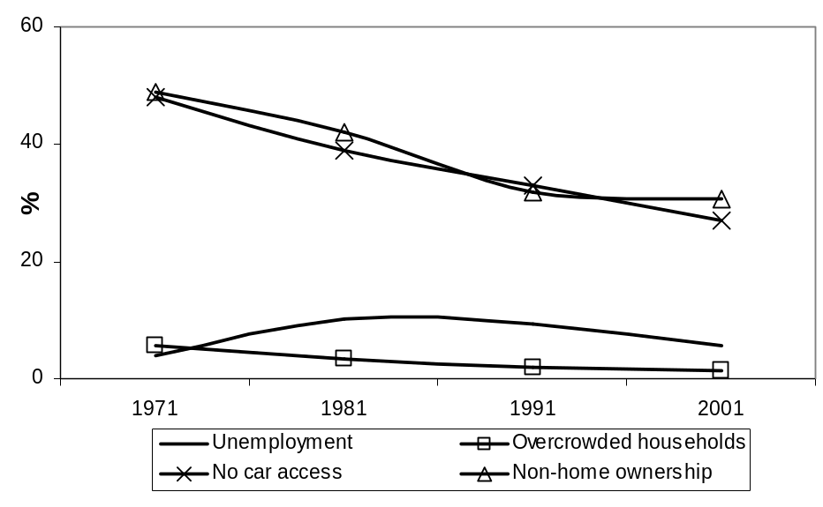

Figure 2a. Changing distribution of CPRE district Townsend deprivation, 1971-2001

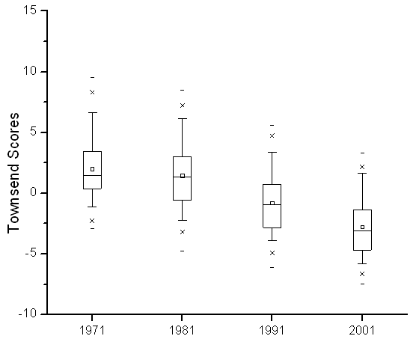

Figure 2b. Changing distribution of CPRE district Breadline Britain, 1970-2000

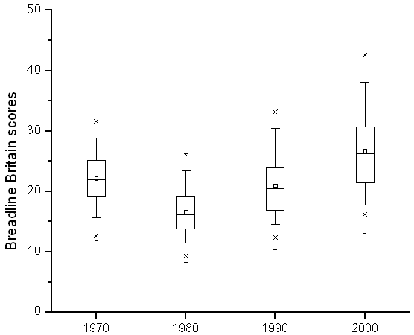

Figure 2c. Relationship between Townsend deprivation and Breadline Britain, 1971-2001

Early 1970s Early 1980s
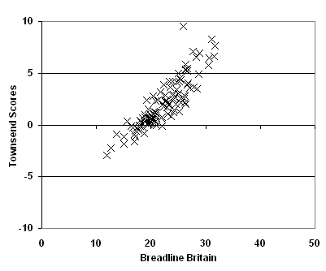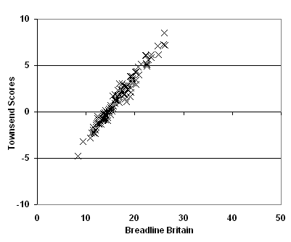

Early 1990s Early 2000s
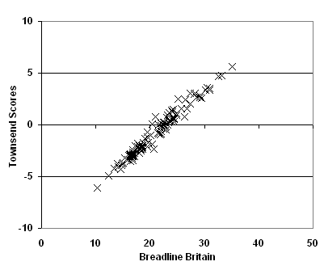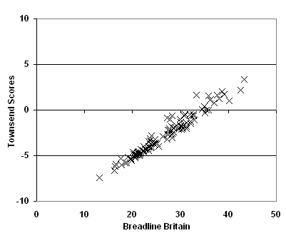

Figure 3a. Relationship of environmental intrusion to Townsend deprivation in England,
1960s-2007
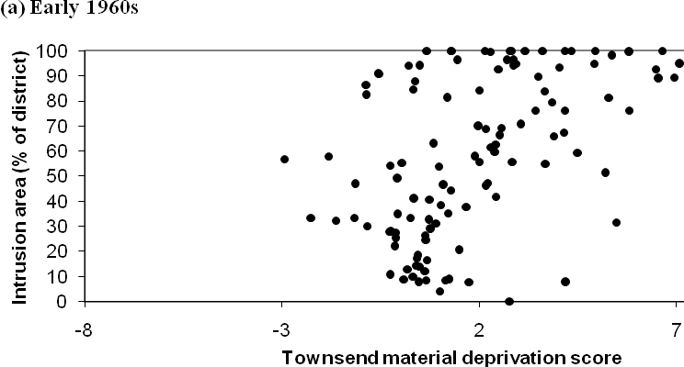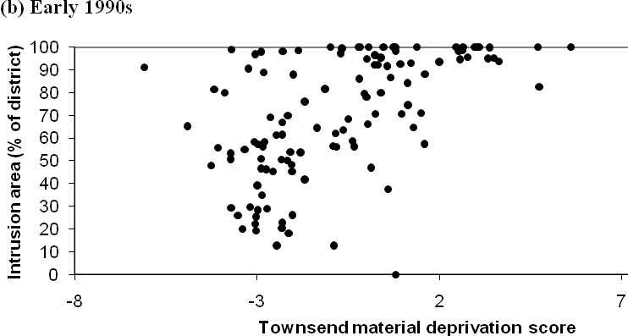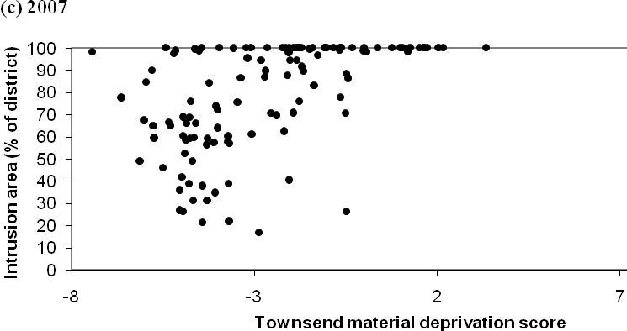

Note: Higher Townsend scores indicate greater deprivation
Figure 3a. Relationship of environmental intrusion to Breadline Britain in England,
1960s-2007

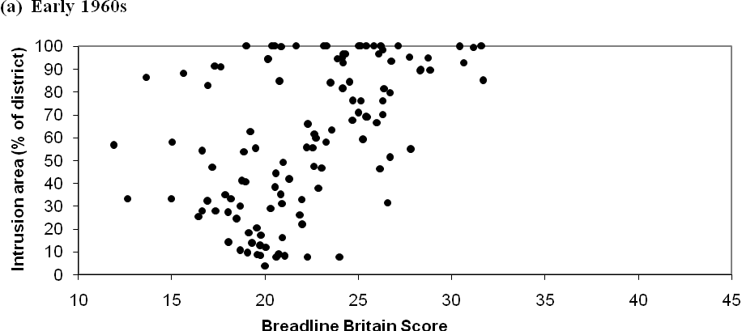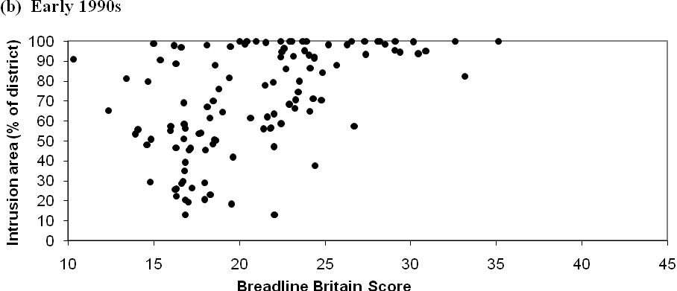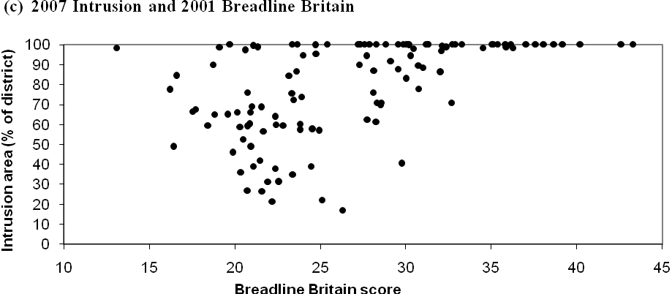
Note: Higher Breadline Britain scores indicate increasing poverty
Figure 4. Environmental intrusion by deprivation decile, England 1960s -2007

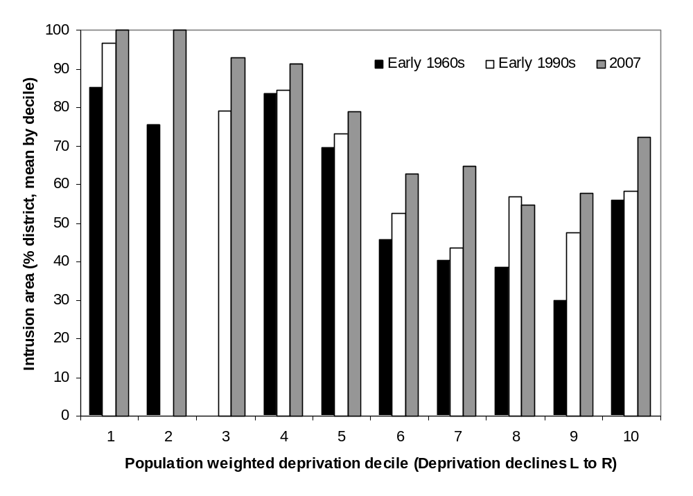

Note: Districts are placed in order of decreasing Townsend material deprivation score and then grouped into deciles of roughly equal population (c. 4.9 million per decile). Missing bars at 2nd and third decile arises as Greater London Authority population (7.5 million) exceeds decile size (and so appears in next decile).

Figure 5. Change in environmental intrusion and deprivation for districts in England

(a) Early 1960s to early 1990s
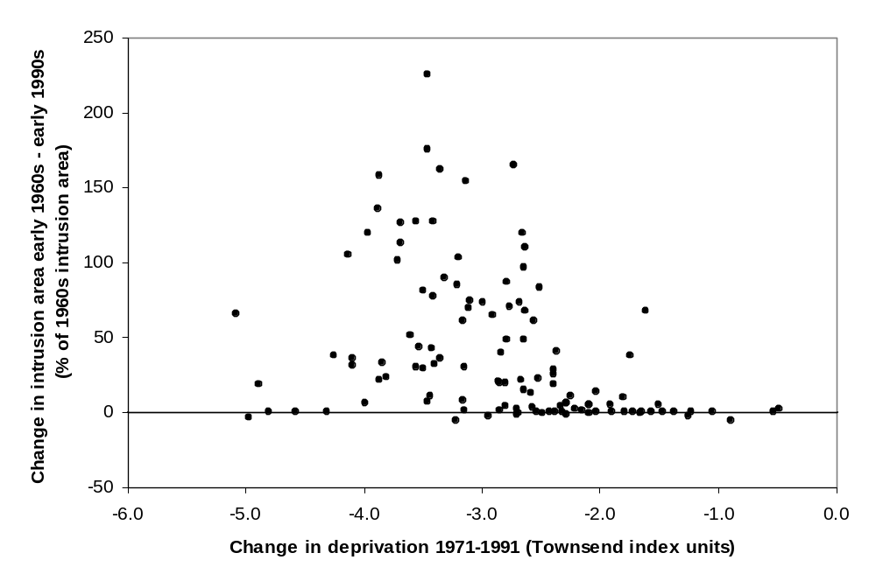

(b) Early 1990s to 2007
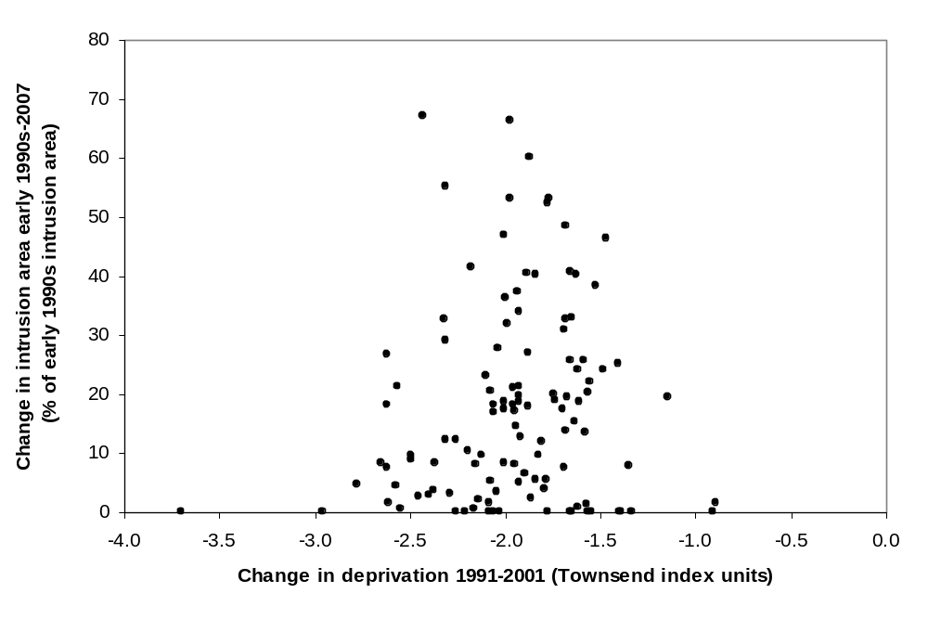

Figure 6. Relationship of changes in environmental intrusion and deprivation in English districts from the early 1960s to 2007

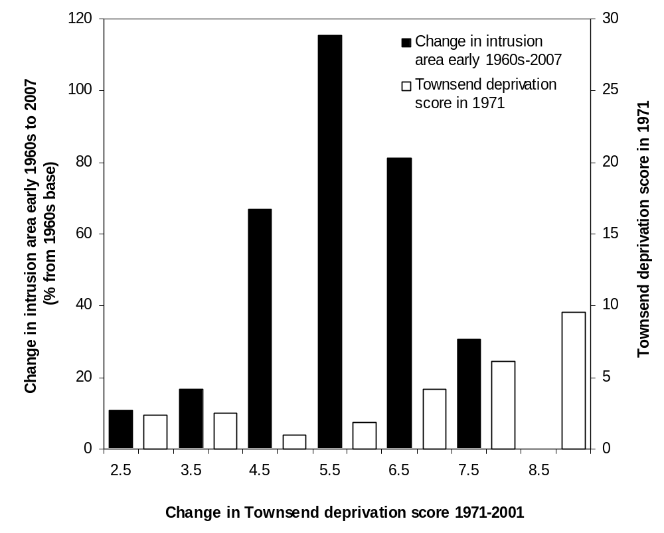

Figure 7. Relationship between changes in population and non-car access: 1971-2001

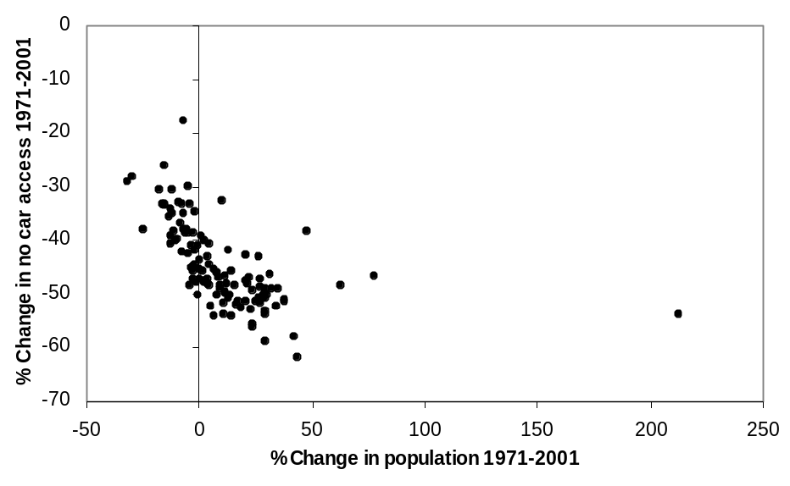
Milton Keynes grew from 66k in 1971 to 207k in 2001

